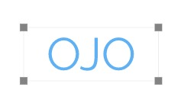

**Weekly Report (WEEK 9)**

**Company Name:** OJO ***e-mail:*** *ojoee@googlegroups.com*

**Members:**

Abdullah Aslam: ***phone:*** *+90 (538) 050 37 64* ***e-mail:*** *ama.abdullah90@gmail.com*

Anar Abdullayev: ***phone:*** *+90 (553) 924 96 43* ***e-mail:*** *abdullayev.1995@gmail.com*

Bulut Ulukapı:  ***phone:*** *+90 (555) 367 26 16*  ***e-mail:*** *ulukapi.bulut@metu.edu.tr*

Syed Saad Saif: ***phone:*** *+90 (546) 781 99 50* ***e-mail:*** *saad.saif@metu.edu.tr*

Umut Can Serçe:***phone*:** *+90 (506) 997 99 88* ***e-mail:*** *serce.umut@metu.edu.tr*

In this week, as we discussed last week, we started studying about our modular coding. We made standardization for the declarations of the headers that we are going to use in the libraries. In addition to this, we also decided what functions will the libraries will be responsible from.

We are going to use an object oriented approach. The feedback-control part will be responsible from other libraries and will act like a controller.

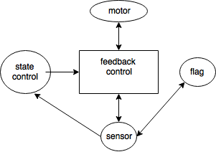

Figure 1. The schematic for the libraries

First of all, we wrote the ultrasonic sensor library and tested it. The result was not satisfying enough. The sensor had problems from certain distances and also did not work well from different angles.

Second, we also tried IR sensor. The sensor did work well enough and from different distances but there was some noise. We thought this noise could be get rid of by using some filter mechanism.

Third, we wrote a library for the motor driver (L298N). Then, we tested the motor driver (L298N) with two motors on a chassis and it worked fine.